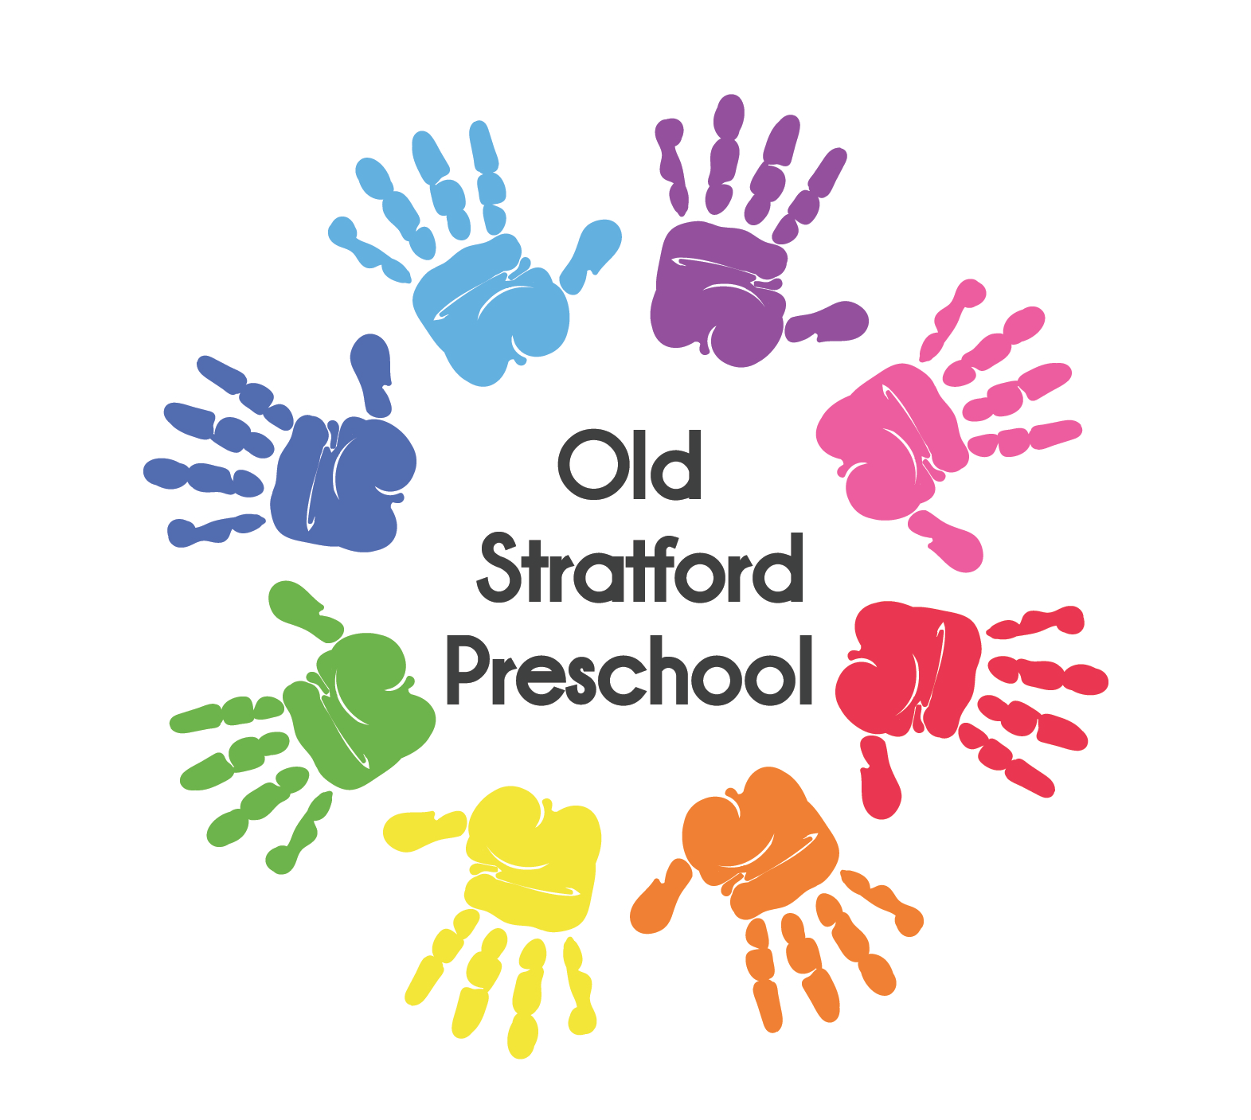

Old Stratford Preschool
Coronavirus (COVID-19) Parent Policy
Old Stratford Preschool take pride in the health and wellbeing of all our staff, parents and children it is extremely important to us.
As with any health concerns, we want to ensure we are minimising the impact and reducing the possibility of exposure in appropriate ways within our Preschool.
Please note that individuals who have symptoms of COVID-19 must not come into the setting and you must keep the Preschool informed.
If your child develops symptoms compatible with coronavirus, they should be sent home and advised to self-isolate for 10 days and book a Covid-19 test. Their fellow household members should self-isolate for 14 days if the Covid-19 test is positive.
If the test is negative, your child is able to return to the setting, if they are well enough. Please note that the Preschool have the right to return you child home should they feel they are still not well enough to return.
If the test is positive, the rest of the children within their childcare or education setting should be sent home and advised to self-isolate for 14 days. The other household members of that wider class or group do not need to self-isolate unless the child, young person or staff member they live with in that group subsequently develops symptoms. In addition to this the Preschool have a duty of care and will ensure parents are aware of any positive cases.
We require the individual to remain out of the child care setting for 14 days following the last potential exposure. If at the end of this 14-day period, the individual has not experienced any symptoms, the individual may return to the child care setting. If the individual does experience symptoms during that 14-day period, the individual will need to obtain medical clearance before returning to the child care setting.
“Typical symptoms of coronavirus include fever and a cough that may progress to severe pneumonia causing shortness of breath and breathing difficulties”
Use the 119 Covid-19 phone number or the online coronavirus service to find out what to do next.
Do not go to a GP surgery, pharmacy or hospital. Call your GP or NHS Covid-19 phone line on 119 for advice.
Where any member of a child’s household is self-isolating for reasons related to Covid-19, they MUST inform the preschool manager before their child attends the preschool. It is under the discretion of the preschool manager to decide if it is safe for the child to attend the setting. Risk assessments should be followed for staff working closely with the affected child and staff will continue to be vigilant.
As you are aware our main priority is the health and wellbeing of our community, including the nursery children, their families and colleagues. The guidance from Public Health England / Wales / Scotland continues to evolve, sometimes on a daily basis therefore please be mindful this policy will adapt and be amended.
It is your responsibility to ensure you keep the Preschool updated and informed. Please do this by telephone or email (manager@oldstratfordpreschool.co.uk)
Thank you for being supportive and considerate in this manner.

This policy was adopted at a meeting of | Old Stratford Preschool | (name of provider)
Held on |  | (date)
Date to be reviewed |  | (date)
Signed on behalf of the provider
Name of signatory
Role of signatory
(e.g. chair, director or owner)

